Heaven’s light is our guide



RAJSHAHI UNIVERSITY OF ENGINEERING & TECHNOLOGY
Department of Mechatronics Engineering

Lab Report

Experiment No.: 06
Experiment Name: 4x4 Matrix Keypad Interfacing using Atmega32 with Proteus Simulation.

Submitted By: | Submitted To:
Samia Afsana  ID: 2008055  3rd Year, Odd Semester  Department of Mechatronics Engineering  Rajshahi University of Engineering & Technology, Rajshahi-6204. | Md Mehedi Hasan  Assistant Professor  Department of Mechatronics Engineering  Rajshahi University of Engineering & Technology, Rajshahi-6204.
Md. Sakib Hassan Chowdhury
Lecturer
Department of Mechatronics Engineering
Rajshahi University of Engineering & Technology, Rajshahi-6204.

Date of Experiment: 18th May, 2024
Date of Submission: 25th May, 2024

MTE 3104
Microcontroller and Interfacing Sessional

Experiment No.: 06

Experiment Name: 4x4 Matrix Keypad Interfacing using Atmega32 with Proteus Simulation.

Objectives:
- To design a circuit for interfacing a 4x4 matrix keypad with an ATmega32 microcontroller.
- To develop code to initialize the keypad and scan for key presses.
- To verify the correct detection of key presses on the 4x4 matrix keypad.
- To demonstrate the practical application of keypad interfacing with a microcontroller.

Theory:

A 4x4 matrix keypad is a common input device used in microcontroller applications for user interaction. It consists of 16 buttons arranged in a matrix of 4 rows and 4 columns. This arrangement allows for the efficient use of I/O pins on a microcontroller, as it reduces the number of connections needed from 16 to 8. The 4x4 matrix keypad is based on the principle of matrix switching. When a key is pressed, it connects a specific row to a specific column, allowing the microcontroller to detect the pressed key by scanning the rows and columns.
A 4x4 matrix keypad consists of:
- 4 Row Lines (R1, R2, R3, R4)
- 4 Column Lines (C1, C2, C3, C4)
Each key on the keypad is positioned at the intersection of a row and a column.

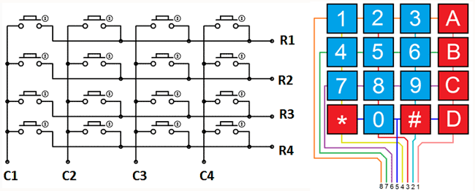

Figure- 6.1: 4x4 Matrix Keypad Pin Configuration [1].

A matrix keypad consists of push button switches that are located at the column and row intersections of a grid or matrix. Switches in the same row are connected together as are switches in the same column.

4x4 Matrix Keypad Pin Configuration:
- Pin1 (R1): This pin is taken out from the first row.
- Pin2 (R2): This pin is taken out from the second row.
- Pin3 (R3): This pin is taken out from the third row.
- Pin4 (R4): This pin is taken out from the fourth row.
- Pin1 (C1): This pin is taken out from the first column.
- Pin2 (C2): This pin is taken out from the second column.
- Pin3 (C3): This pin is taken out from the third column.
- Pin4 (C4): This pin is taken out from the fourth column.
To detect a pushed key, the microcontroller will ground all the rows in the matrix by simply providing zero to the o/p pins, after that it reads the columns in the matrix. If there is no key is pushed, then the data read in the matrix from the column will be 1111. Pushing a button in the matrix then it shorts the row lines to column lines by allowing the flow of current between them. So, for instance, when key1 is pushed then row 1 & column 1 will be shorted. If the C1 bit value (first column) is ‘0’, the key button1 is pressed. So, for instance, if C1 C2 C3 & C4 = 0111, then a key within column C1 has been pushed. Thus, this procedure will continue for all rows as well as columns [2].
In this lab, we aim to interface a 4x4 Matrix Keypad with the Atmega32 microcontroller and simulate the design using Proteus. Matrix keypad is used in embedded systems for displaying the pressed key.

Working Principle:
- The corresponding software was set up. Then the necessary libraries were included for I/O operations and delay functions.
- The LCD library was also included for display operations.
- The variable was initialized to store the detected key value and the PORTA was configured as input.
- The getKeyPressed function is responsible for scanning the keypad and detecting which key, if any, is pressed. When a key was pressed, the corresponding row and column were detected, and the key value was calculated.
- The detected key value was then displayed on the LCD, providing real-time feedback to the user.

Required Components:
- Atmega32 Microcontroller
- 16x2 LCD
- Power
- Wire
- Ground
- Resistor
- Capacitor
- Potentiometer
- Push Button

Code:

#define NO_KEY 0xFF

#define ROW_SIZE 4
#define COLUMN_SIZE 4

#include <avr/io.h>
#include <util/delay.h>
#include "lcdlib/lcd_lib.h"

static uint8_t getKeyPressed(void);

int main(void) {
uint8_t key_value = NO_KEY;

_delay_ms(100);

DDRA = 0x00;
PORTA |= 0x0F;

LCDinit();
LCDWriteStringXY(2, 0, "Matrix Keypad");
_delay_ms(2000);

LCDclr();
LCDWriteStringXY(0, 0, "Key");
LCDWriteStringXY(0, 1, "Pressed Key=");

/* Replace with your application code */
while (1) {
key_value = getKeyPressed();

if (key_value != NO_KEY) {
LCDWriteIntXY(12, 1, key_value, 2);
}
_delay_ms(100);
}
}

static uint8_t getKeyPressed(void) {
uint8_t row, column;
PORTA = 0x0F;

for (column = 0; column < COLUMN_SIZE; column++) {
DDRA &= 0x00;
DDRA |= (0x80 >> column);

for (row = 0; row < ROW_SIZE; row++) {
if (!(PINA & (0x08 >> row))) {
return ((row * COLUMN_SIZE) + column);
}
}
}

return NO_KEY;
}

Figures:

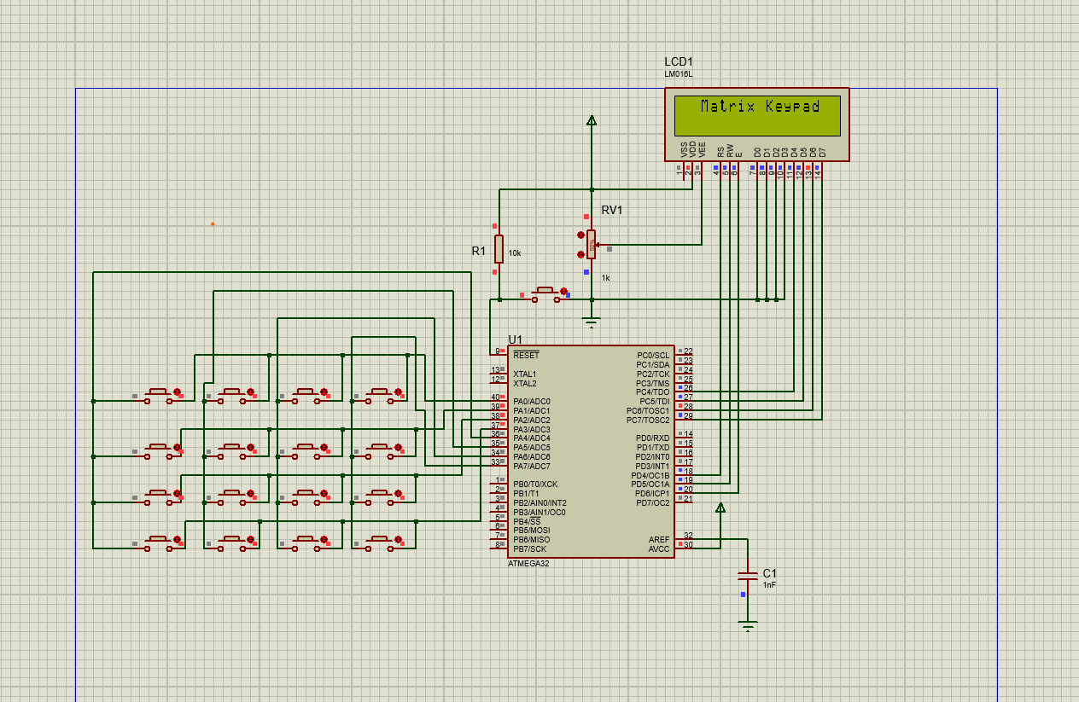

Figure-6.2: 4x4 Matrix Keypad Circuit (No pressed Key)

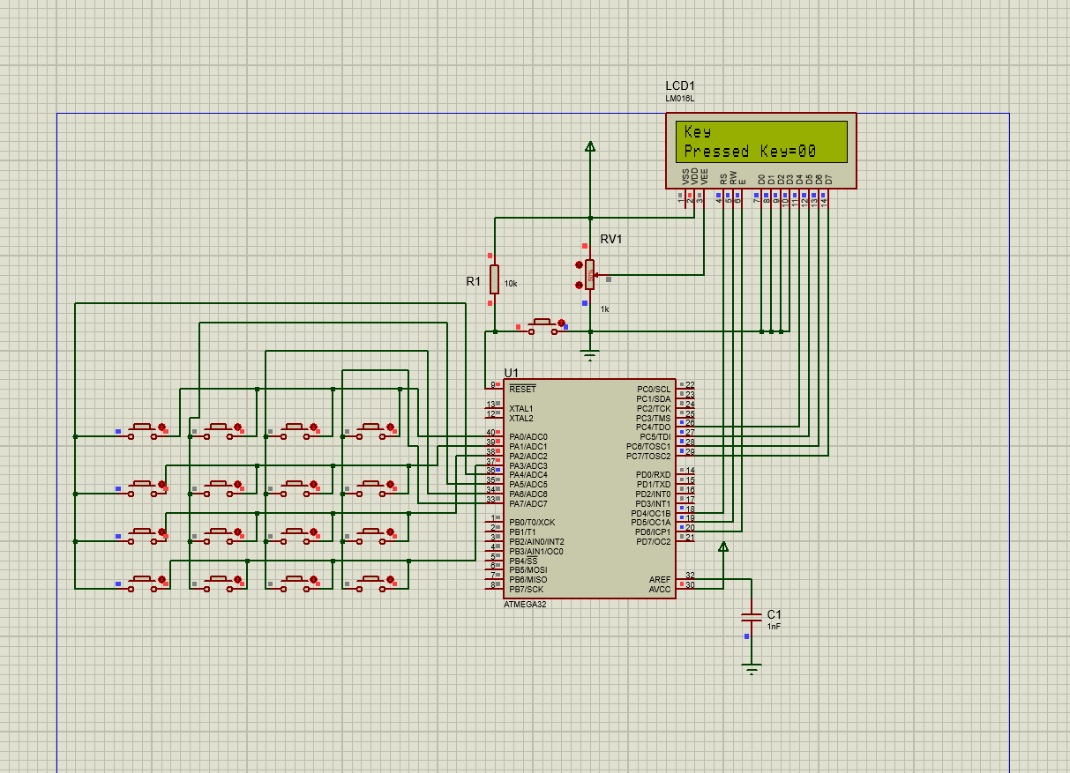

Figure-6.3: 4x4 Matrix Keypad Circuit (Pressed Key 00)

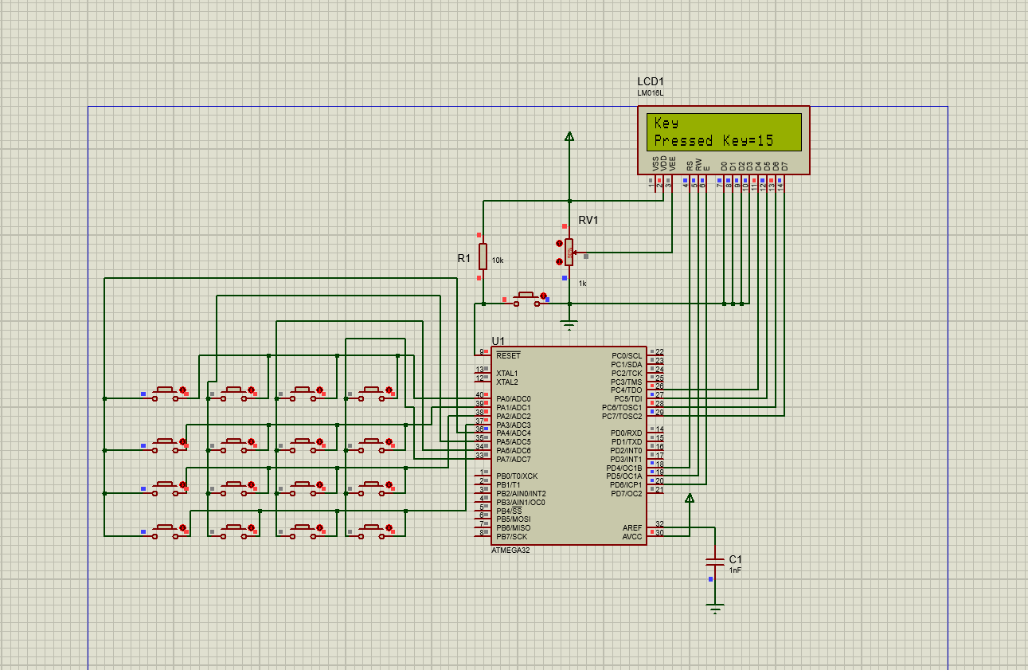

Figure-6.4: 4x4 Matrix Keypad Circuit (Pressed Key 15)

Discussion:

During the simulation, the circuit was successfully implemented using 4x4 Matrix Keypad in Proteus software. The Atmega32 microcontroller accurately controlled the 4x4 Matrix Keypad to display the pressed Key value. The given pressed key value was displayed in the 16x2 LCD screen properly. The pressing any key on the virtual 4x4 keypad was correctly detected on the LCD screen. The interfacing between the microcontroller and the matrix keypad was seamless, demonstrating the effectiveness of the design.

Practical Uses:

- Security Systems: For entering PIN codes in door locks or safes.
- Calculators: As the primary input method for mathematical operations.
- Telecommunication Devices: For dialing numbers on phones.
- Consumer Electronics: For menu navigation in devices like microwaves, washing machines, and remote controls.
- Industrial Control Panels: For inputting commands in machinery and equipment.

Conclusion:
Understanding the theory behind a 4x4 matrix keypad is crucial for effectively interfacing it with a microcontroller like the ATmega32. The microcontroller was able to accurately detect and respond to key presses, demonstrating effective keypad scanning and interfacing. By using a matrix scanning technique, the keypad can be efficiently read with minimal I/O pin usage, making it an ideal input method for various embedded systems applications. The simulation in Proteus further aids in visualizing and verifying the functionality of the interfaced keypad, ensuring reliable performance in real-world scenarios.

References:

[1] 4x4 Matrix Keypad Pin Configuration [Online]. Available:
https://circuitdigest.com/microcontroller-projects/keypad-interfacing-with-8051-microcontroller (2023)

[2] 4x4 Matrix Keypad [Online]. Available:
https://www.watelectronics.com/4x4-keypad-module/ (2023)

